Expression

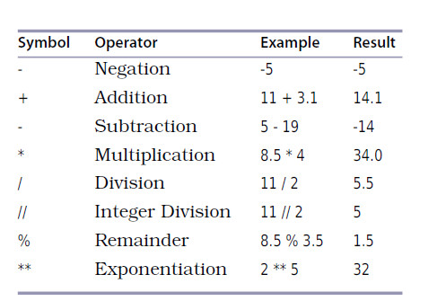

Logical Operators
Operator | Description | Example
and Logical AND | If both the operands are true then condition becomes true. | (a and b) is true.
or Logical OR | If any of the two operands are non-zero then condition becomes true. | (a or b) is true.
not Logical NOT | Used to reverse the logical state of its operand. | not(a and b) is false.

Assignment Operators

Operator | Description | Example
= | Assigns values from right side operands to left side operand | c = a + b assigns value of a + b into c
+= Add AND | It adds right operand to the left operand and assign the result to left operand | c += a is equivalent to c = c + a
-= Subtract AND | It subtracts right operand from the left operand and assign the result to left operand | c -= a is equivalent to c = c - a
*= Multiply AND | It multiplies right operand with the left operand and assign the result to left operand | c *= a is equivalent to c = c * a
/= Divide AND | It divides left operand with the right operand and assign the result to left operand | c /= a is equivalent to c = c / ac /= a is equivalent to c = c / a
%= Modulus AND | It takes modulus using two operands and assign the result to left operand | c %= a is equivalent to c = c % a
**= Exponent AND | Performs exponential (power) calculation on operators and assign value to the left operand | c **= a is equivalent to c = c ** a
//= Floor Division | It performs floor division on operators and assign value to the left operand | c //= a is equivalent to c = c // a

Comparison Operators
Operator | Description | Example
== | If the values of two operands are equal, then the condition becomes true. | (a == b) is not true.
!= | If values of two operands are not equal, then condition becomes true.
> | If the value of left operand is greater than the value of right operand, then condition becomes true. | (a > b) is not true.
< | If the value of left operand is less than the value of right operand, then condition becomes true. | (a < b) is true.
>= | If the value of left operand is greater than or equal to the value of right operand, then condition becomes true. | (a >= b) is not true.
<= | If the value of left operand is less than or equal to the value of right operand, then condition becomes true. | (a <= b) is true.

